**“Capital university of science and technology Islamabad”**

***Member_Name 1:***

***Afshan Liaquat***

***BCS201019***

***Member_Name 2 :***

***Rimsha Liaquat***

***BCS201018***

***Section:***

***01***

***Subject:***

***DATA BASE***

***Submitted to :***

***Sir Basit***

***Date :***

***7/7/2021 ,5:53 PM***

***Title:***

***DATABASE FINAL PROJECT***

**Sale and Purchase system**

***OUTLINE***

* ***Introduction***
* ***Abstraction***
* ***Requirements***
* ***Conceptual Design(ER Diagram)***
* ***Analysis***
* ***Logical design***
* ***Outputs***

***Introduction:***

**Purchase** is a process through which a person gets the ownership of some goods or properties transferred in his name from another, on payment of money. **Sale** is a process through which the ownership of some goods or properties is transferred from one person (seller) to another person (buyer), for a price. It was very difficult to store the records of sale and purchase in register and it was difficult and time taking to search or retrieve some kind of record from registers so then, database is use in trading system and it’s easy to store record and search the record of customer or item.

**Abstraction:**

For the sale and purchase system we have created a Database. We make the system where when the customer purchases any item or product from the supplier, his or her complete record and product record will be entered in to a database for future record. And Supplier will keep record of the product which are sold and quantity of products or items left.

**Php, connection to Database and CSS files:**

1.

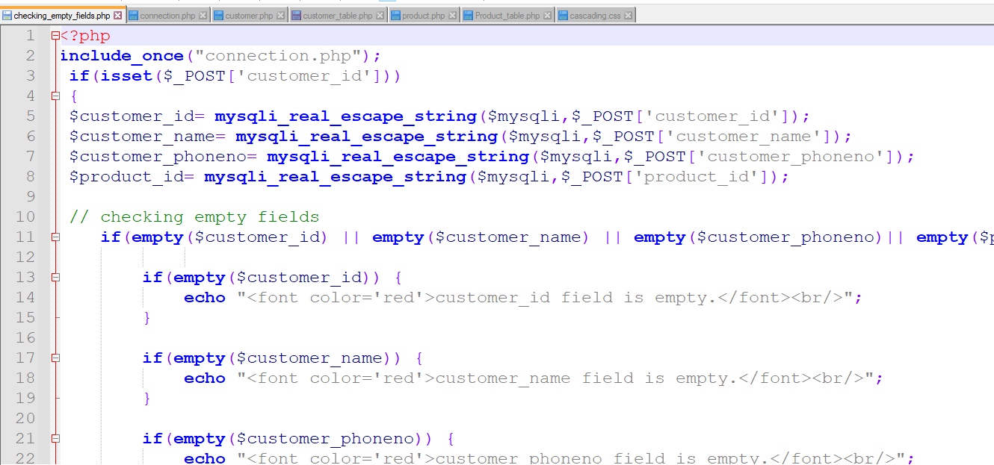

2.

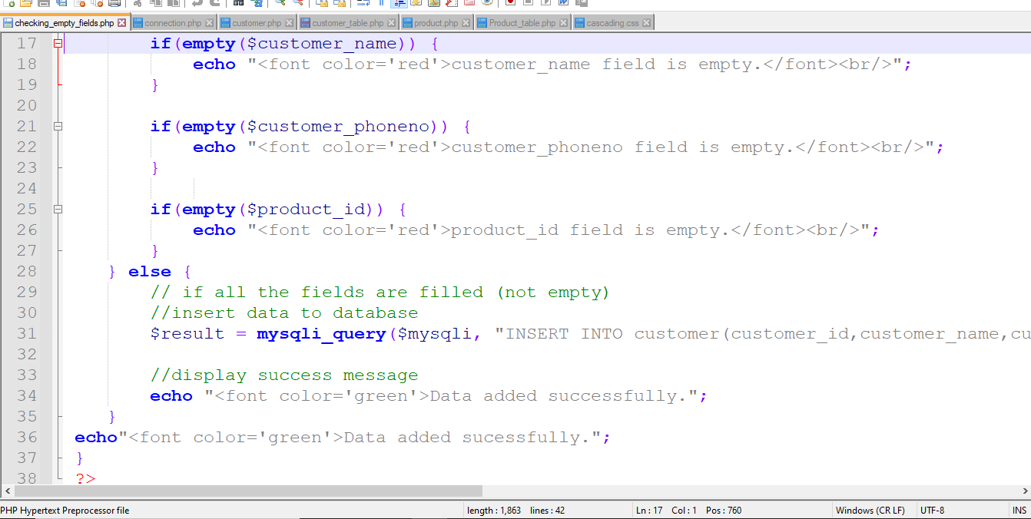

3.

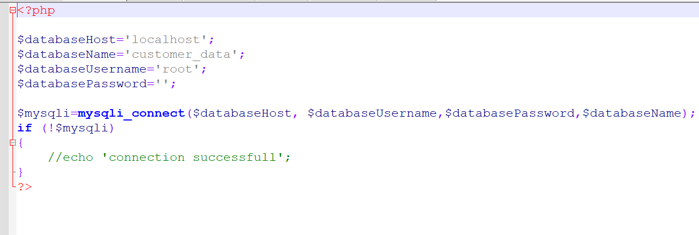

4.

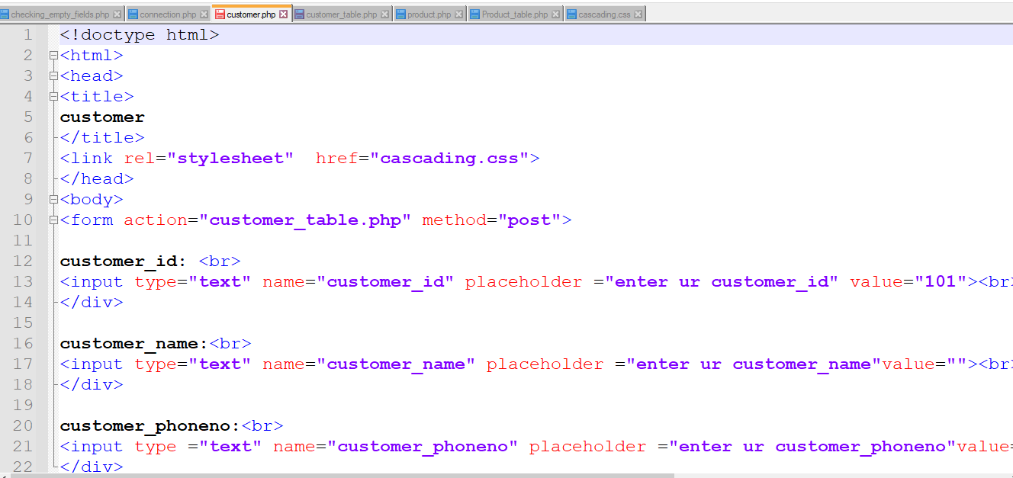

5.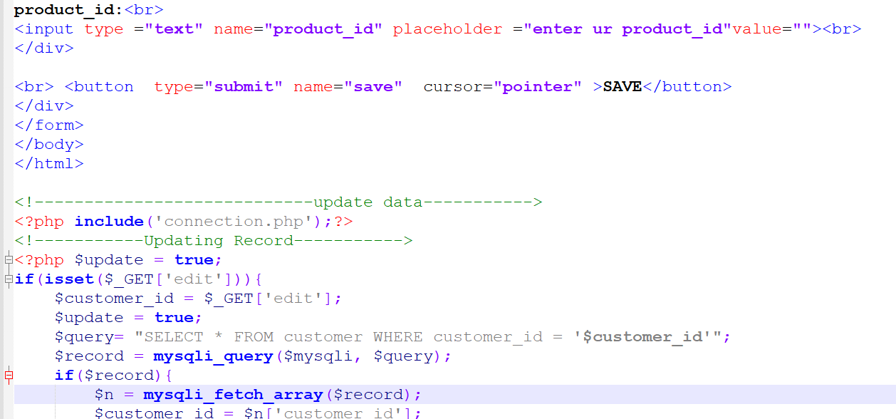

6.

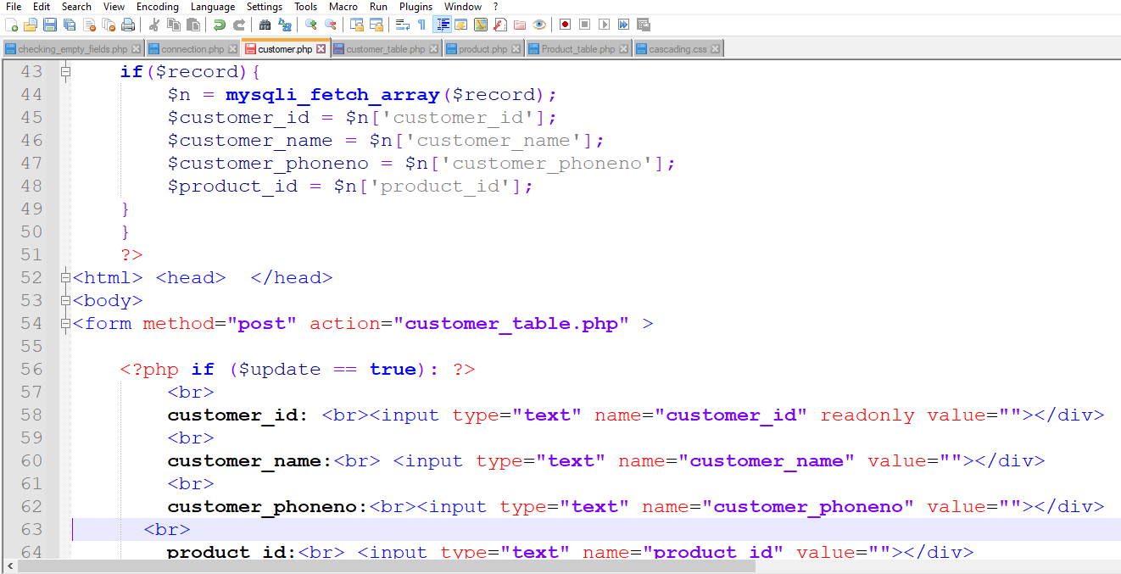

7

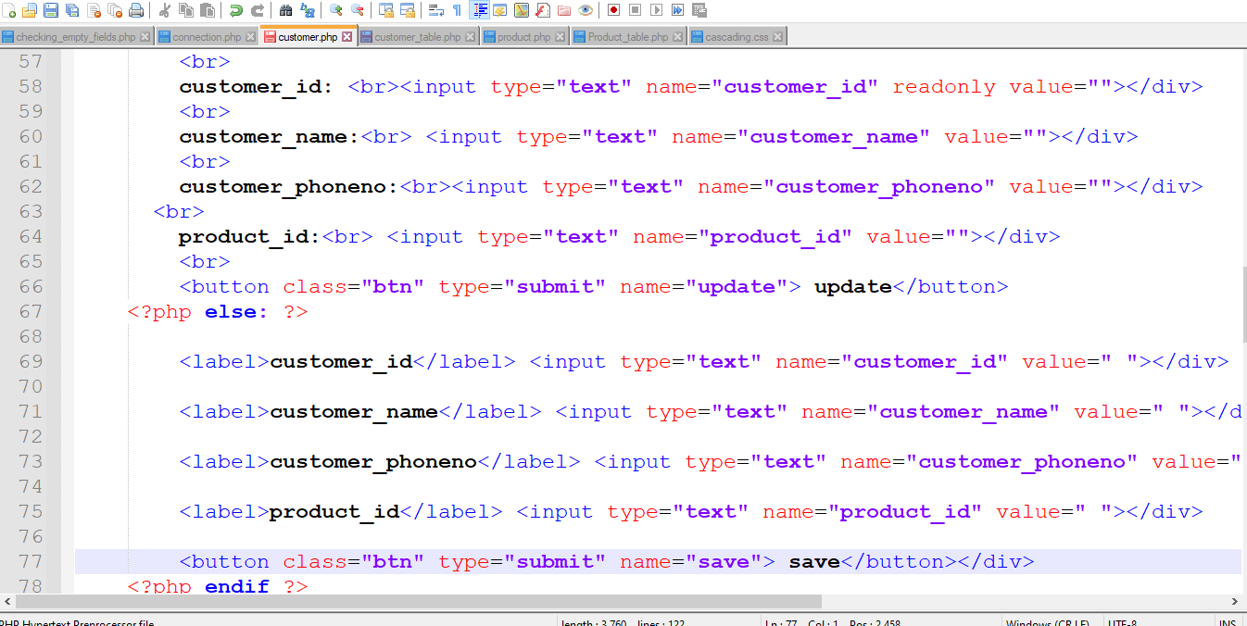

8.

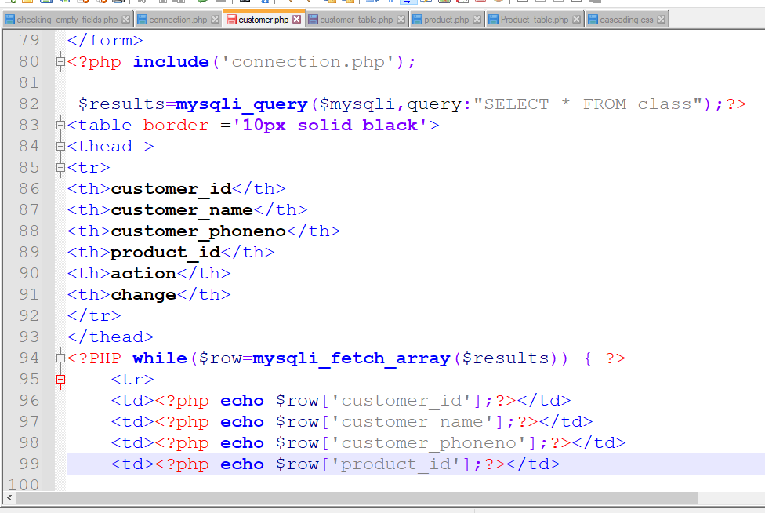

9.

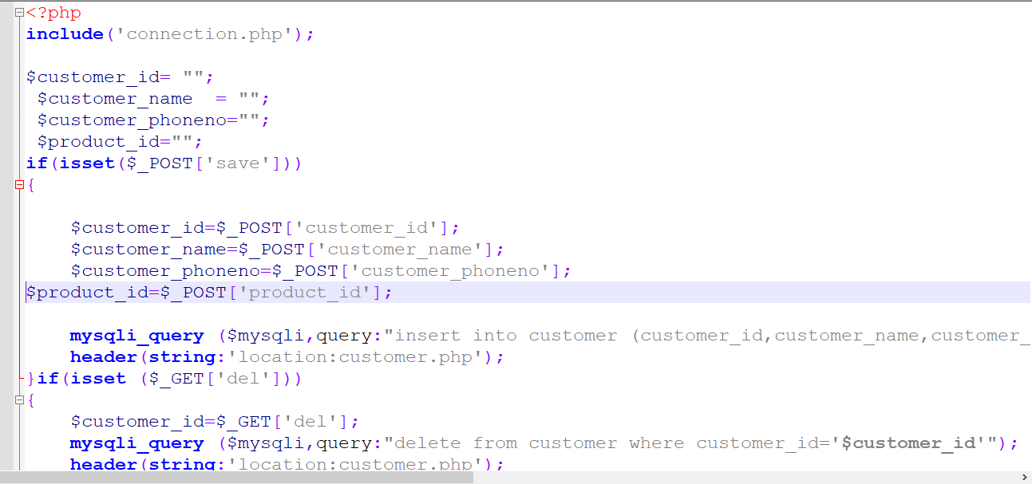

10.

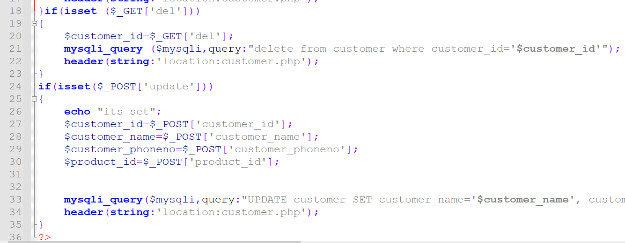

11.

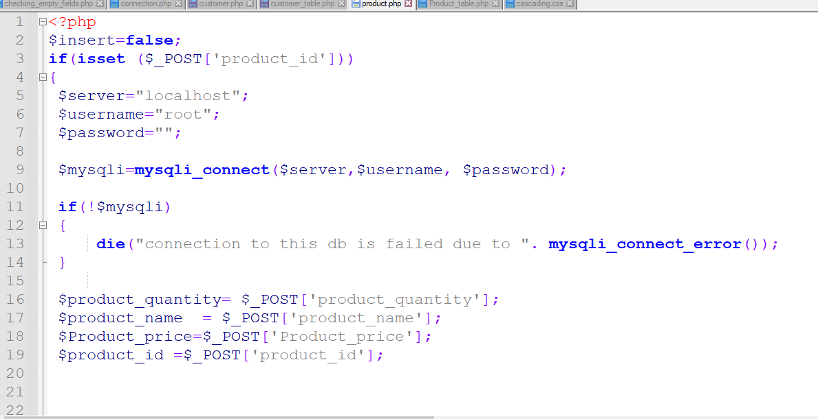

12.

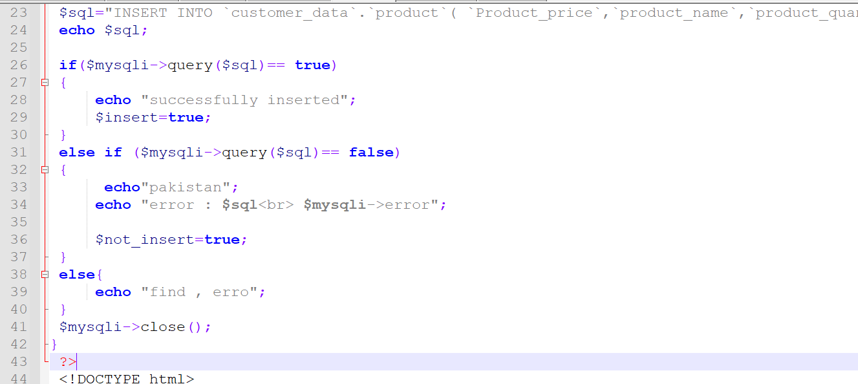

13.

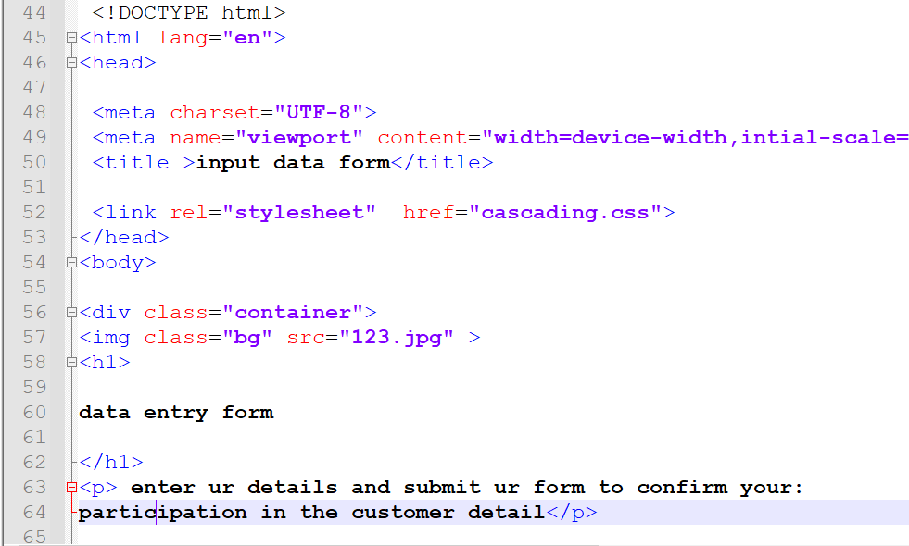

12.

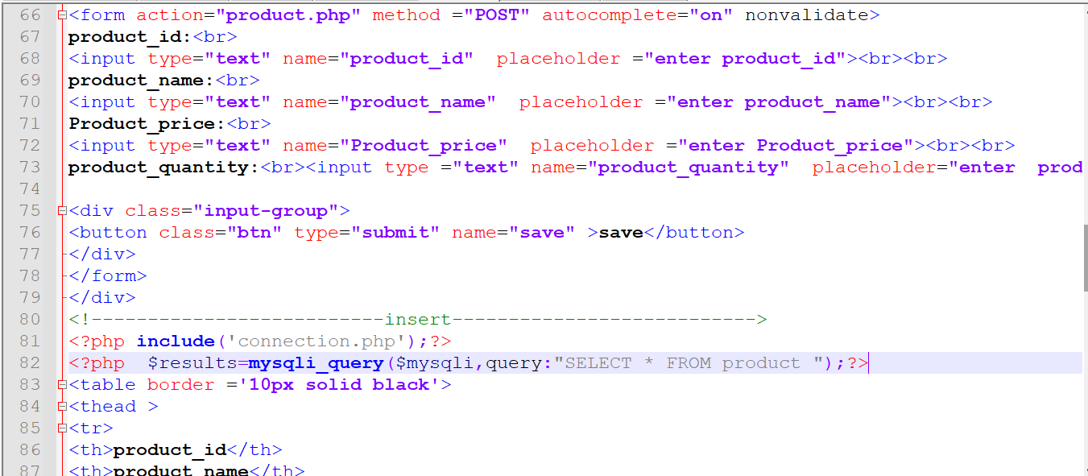

13.

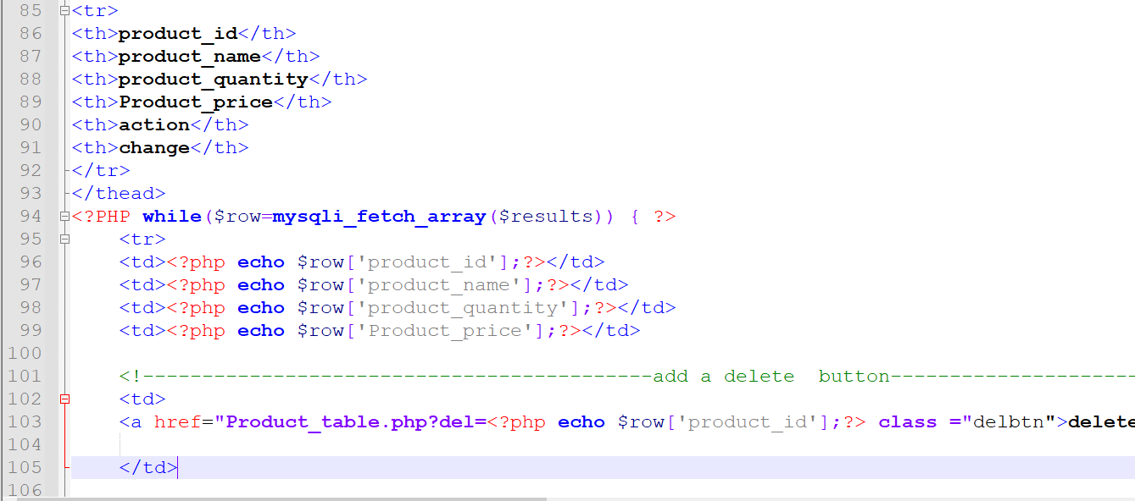

14.

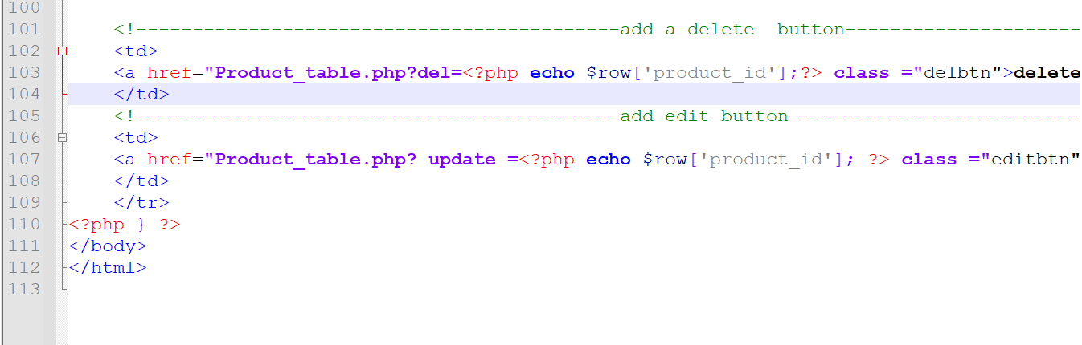

15.

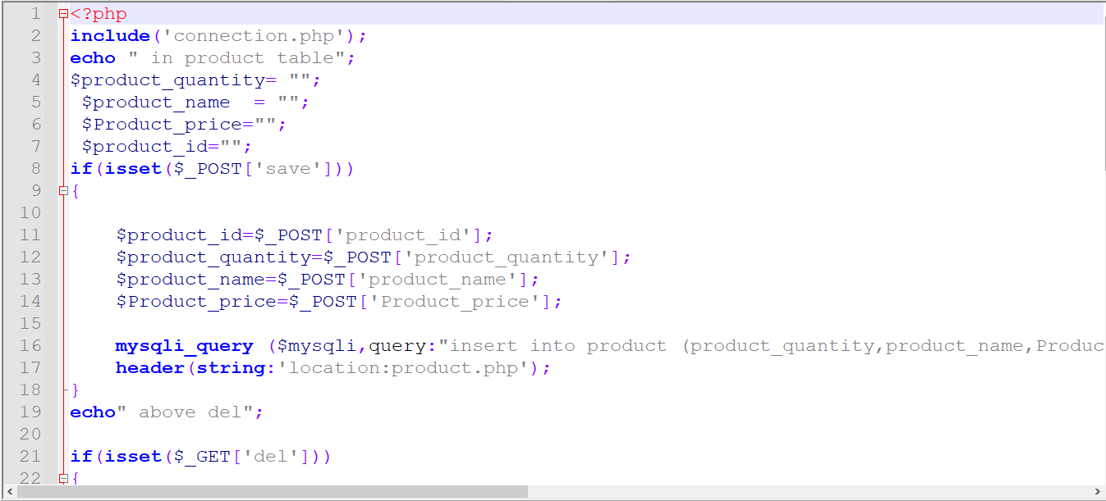

16.

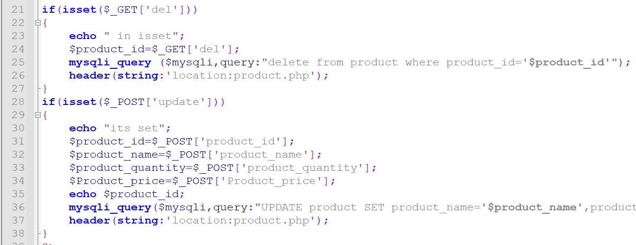

***Requirements:***

***We use tables:***

***Customer (customer_id, customer_name, customer_phone_no, purchase_date,product_id)***

***Product ( procduct_id, product_name, product_price, product_quantity)***

***Supplier( Serial_No, item_price, total_items,Purshase_amount,purchase_date);***

***ER Diagram( Conceptual Design)***

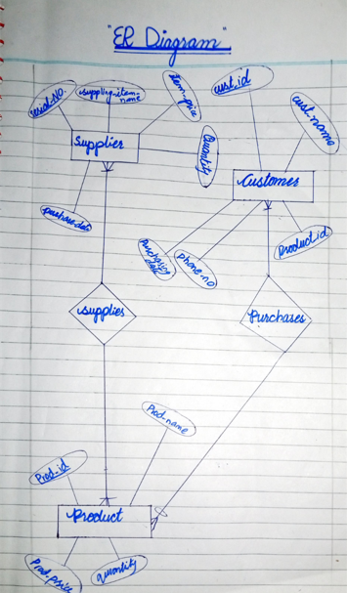

17.

***CSS :***

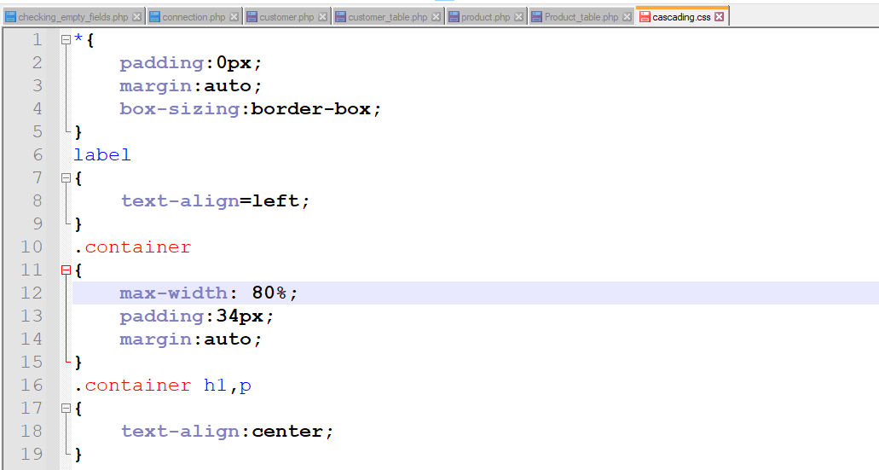

18.

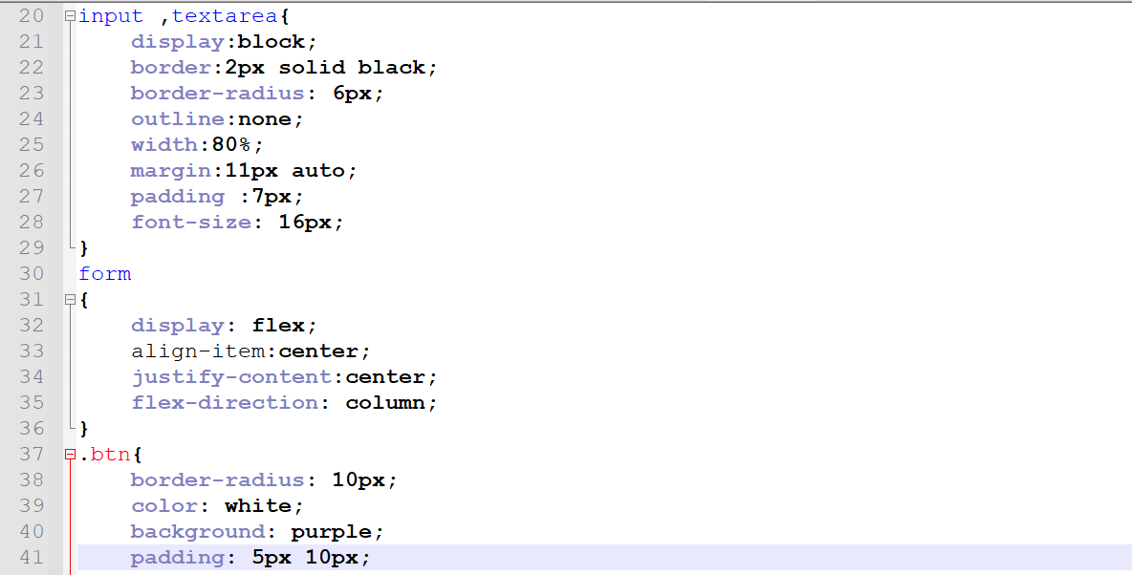

19.

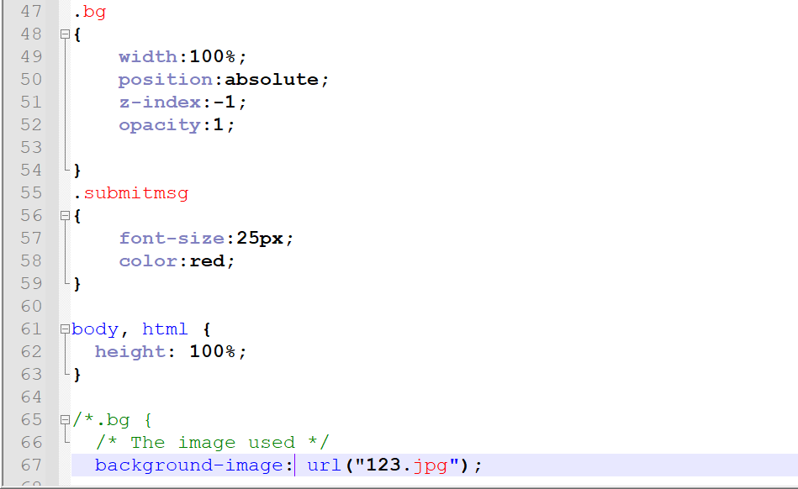

20.

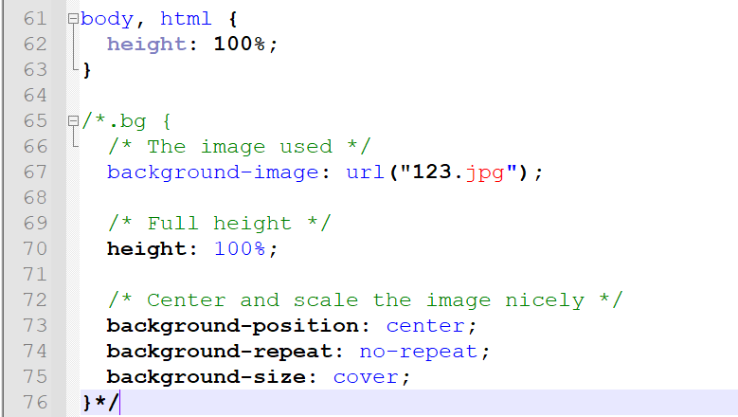

***OUTPUTS:***

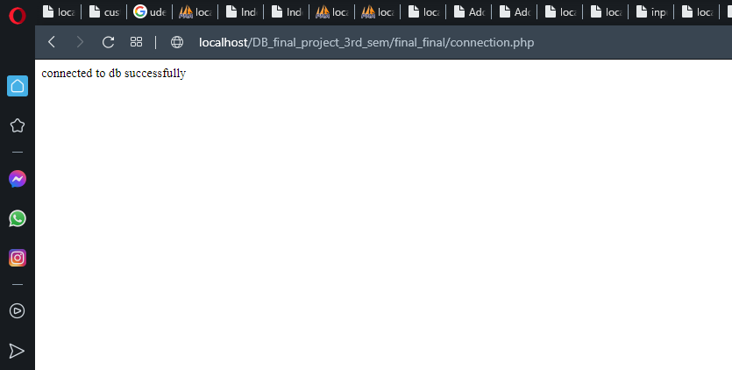

1.

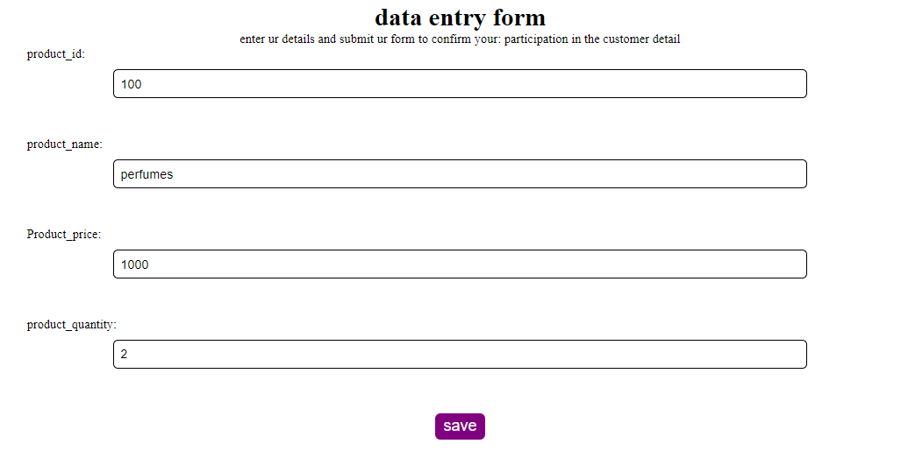

***Relational designs:***

